Future Multi-Agency Regional GIS – Phase III – Governance Review and Refinement

Lane Council of Governments

Introduction 1

Governance Summary 3

Phase II Governance Recommendations 6

Phase III Governance Feedback 10

Q 01: Please tell us about yourself: What is your name, title, and organization you are associated with. 12

Q 02: What are the aspects of the current CPA governance structure you like the most? 13

Q 03: What CPA governance aspects would you like 14

changed/augmented/eliminated/added? 14

Q 04: What is the single most important governance function to ensure CPA success? 16

Q 05: The following is a list of subcommittees listed in various formative documents. Most of them existed at some time. What sub-committees do you feel are the most valuable? Please rank them from 0-12 (0 being of 17

no value, 12 being indispensable). 17

Q 06: Do you have any ideas for new 17

subcommittees? 17

Q 07: How important is the funding of a grant position to seek funds for the region? (0 of no importance, 10 imperative) 19

Q 08: How important is the existence of a Regional Geospatial Executive Team (RGET) of executives to support, guide, and prioritize the CPA? (0 of no importance, 10 imperative) 20

Q 09: In regards to RGET, what ideas do you have about its purpose, membership, and/or role? 21

Q 10: How important is the existence of a Regional GIS Coordinator’s Team? (0 of no importance, 10 imperative) 22

Q 11: What do you think is the most important functions of the team? 23

Q 12: In regards to the GIS Coordinator’s team, what ideas do you have about additional responsibilities, changes, membership, etc.? 24

Q 13: How important is the existence of a service catalog to the health of the CPA? (0 of no importance, 10 imperative) 25

Q 14: Do you have any comments on the importance of the existence of a service catalog to the health of the CPA? 26

Q 15: Do you have any ideas about how this service catalog should be maintained and socialized? 27

Q 16: Do you believe that LCOG should continue to be the coordinating entity? 28

Q 17: How do you believe the coordination should be 29

changed/augmented/improved? 29

Q 18: How important is the existence of an annual work plan to the health of the CPA? (0 of no importance, 10 imperative) 30

Q 19: Do you have any comments on the importance of the existence of an annual work plan to the health of the CPA? 31

Q 20: How important are quarterly financial updates to the health of the CPA? (0 of no importance, 10 imperative) 32

Q 21: Do you have any comments on the importance of quarterly financial updates to the health of the CPA? 33

Q 22: How important is an annual Voice of the Customer Survey (CPA membership version) and report to the health of the CPA? (0 of no importance, 10 imperative) 34

Q 23: Do you have any comments on the importance of an annual Voice of the Customer Survey (CPA membership version) and report to the health of the CPA? 35

Q 24: How important is an annual Key Performance Indicator Update and report to the health of the CPA? (0 of no importance, 10 imperative) 36

Q 25: Do you have any comments on the importance of an annual Key Performance Indicator Update and report to the health of the CPA? 37

Q 26: How important is an annual alignment study (how the CPA aligns with and supports the goals of each agency) and report to the health of the CPA? (0 of no importance, 10 imperative) 38

Q 27: Do you have any comments on the importance of an annual alignment study (how the CPA aligns with and supports the goals of each agency) and report to the health of the CPA? 39

Q 28: How important is it for the coordinating agency (LCOG) to take on the role of promoting and incubating innovation to the health of the CPA? (0 of no importance, 10 imperative) 40

Q 29: Do you have any comments on the importance of the coordinating agency (LCOG) to take on the role of promoting and incubating innovation to the health of the CPA? 41

Q 30: How supportive are you of the Regional Center of Excellence Model? (0 not at all supportive, 10 very supportive) 42

Q 31: Do you have any comments on the Regional Center of Excellence Model? 43

Q 32: Any other final thoughts or comments? 44

Governance Conclusion 45

Introduction

This document is the first of the final phase (Phase III) of a multi-year effort to **examine, define, and restructure** a long-standing multi-jurisdictional Cooperative Partnership Agreement (CPA) between partner agencies (the partners), including the City of Eugene, City of Springfield, Eugene Water and Electric Board (EWEB), Lane County, and Lane Council of Governments (LCOG). A partnership that includes regionally shared data systems and services. A number of documents have been delivered thus far in an effort to systematically lay the groundwork for the creation of proposed CPA alternatives. Previous documents have included a Stakeholder Identification Report, a Voice of the Customer Survey Report, a Partner Interview Report, a SWOT Report, and a Needs Assessment Findings Report (Phase 1). All of these reports, a wealth of background material, and a year-long feedback loop with partner agencies led to a ***Future Multi-Agency Regional GIS Model Alternatives Report (Phase II)***.

This report further refines the governance model that will guide the CPA into the future. A **GIS Governance Model** is a structure and process that can facilitate GIS technology growth and use. A Regional Governance strategy can be complex and problematic, but the right governance strategy is critical for effective technology diffusion. The appropriate governance strategy is even more important when considering multi-organizational/shared GIS resources. **The number one reason that regional GIS programs fail, or do not live up to their potential, is a poor or misaligned governance strategy.**

The selection, therefore, and implementation of the right governance strategy could give rise to positive and beneficial characteristics. Alternatively, the selection and/or implementation of a poorly suited governance strategy can have negative consequences. The following table contrasts the results of good regional GIS governance against that of misguided regional GIS governance.

|  |  |
| --- | --- |
| **GOOD GIS GOVERNANCE**  **STRATEGY RESULTS:**   * Reduces duplication of effort amongst agencies * Regionalizes data sharing and access * Continuity of data and accuracy * Assists with data interchangeability * Provides leadership on regional concerns and provides a conduit for regional efforts (Public Safety, Emergency Operations, Transportation, Environmental, etc.) * Supports effective, strategic decision making * Optimization of education and knowledge transfer * Region-wide resource planning * Clear lines of roles, responsibility, and accountability * Easy geographic information exchange * Timely response to internal and citizen GIS requests and questions * End-user participation * Stakeholder consent building * Increased productivity * Accurate information, map data, and statistical reports * Working as a team * Regional sustainability | **MISGUIDED OR LACK OF**  **GIS GOVERNANCE STRATEGY RESULTS:**   * Data silos and duplication * Poor decision making based on disjointed regional data * Misinformed public * Data and process duplication * Lack of regional geospatial programs and regional perspective Public Safety, Emergency Operations, Transportation, Environmental, etc.) * Variations in priorities * Lack of financial optimization * Information hoarding or missing information * Inability to locate critical or timely information * Insensitivity to users’ needs * Insufficient prevention and response * Inefficient decision making * Poor training and education * Poorly maintained, misplaced and stale information * Everyone going their own way * Poor organization performance * Missed opportunities that can only be accommodated from a regional context |

The remainder of this document will a) organize in one place the governance recommendations from the CPA alternatives document and b) refine the recommendations based on feedback garnered through follow up discussions with the Regional GIS Coordinator’s Team and an online survey distributed to them.

Governance Summary

Phase II of this project focused on a review of the existing CPA and future multi-agency regional GIS model alternatives. A key component of the CPA alternatives was governance. The existing CPA was created decades ago and did establish governance with the following key governance elements:

* Included the following local government agencies as the parties to the agreement:
  + Lane County, a political subdivision of the State of Oregon;
  + City of Eugene, a municipal corporation of the State of Oregon;
  + City of Springfield, a municipal corporation of the State of Oregon;
  + Eugen Water and Electric Board, a public utility;
  + Lane Council of Governments, an association of governments.
* Established a number of committees (page 10 of the Phase II document) to guide and govern the CPA. Many of these committees are defunct.
* A Common Mapping Steering Committee was formed as a policy board focused on GIS. This has since morphed into the GIS Coordinator’s Team.
* The existing CPA calls for the creation of an annual budget and work plan.
* A GIS/Common Mapping/RLID Agreement Appendix was added to the CPA to further clarify the regional GIS effort (page 12 -13 of the Phase II document). This Appendix identified the following governance-related items:
  + Secure agency support through formalized data sharing agreements;
  + Support of the regional GIS from high-level policymakers;
  + Maintaining policy committees with the authority to commit resources;
  + Each agency contributes its own agency plans and needs for regional issues through formalized committees;
  + Maintain a designated coordinating entity for project coordination and effort (LCOG fills this role).
* The existing CPA called for a Regional Executive Board to give oversight and direction. This Board does not currently exist nor has it convened for many years.
* Therefore governance of the regional GIS effort has been left to LCOG under the advisement of the GIS Coordinator’s Team.
* Historically (pre-CPA), a Common Mapping Steering Committee (CMSC) was established as a coordinating body to advise and coordinate geospatial activities for the region. The CMSC gave oversight to the creation of a comprehensive plan to create a strategy for the regional GIS effort. A document titled, “Geographic Information System Management Strategy”, was created in 1993 under the direction of the CMSC and updated numerous times. This document laid the groundwork for officializing the management of GIS for the region. Also, the CMSC was the logical leadership team to fill the role of the Regional Geographic Information System (GIS) team identified in the CPA. After the CPA, the CMSC was renamed the Regional GIS Steering Committee and the regional strategy was updated in the Regional GIS Management Strategy 2001-2004 document. This document was critical to the establishment of the regional GIS framework and identifying key service areas that are the foundation of the regional GIS effort. These documented functions have become the foundation for the actions taken towards the overall regional geospatial effort as officialized within the CPA.
* The Regional GIS Management Strategy 2001-2004 had the following key elements:
  + A vision/mission of the regional GIS effort (page 15 of the Phase II document);
  + Continuant of monthly technical user group meetings;
  + Training plan for new managers;
  + LCOG to continue the established role of coordinating the CMSC and associated sub-committee meetings;
  + Presentations to the Regional Executive Group (REG) pertaining to the regional GIS;
  + Annual GIS open house and workshops for managers, elected officials, and other stakeholders;
  + Recommended a governance committee structure that featured a mix of regional and agency committees and subcommittees;
  + A number of subcommittees were formed but no longer meet as a result of budget constraints;
  + Regional Executive Group (REG) was mandated to provide overall policy direction for the regional GIS. The REG was not propagated and is now defunct.
  + A Common Mapping Steering Committee (CMSC) was empowered by setting the direction and managing coordination for the regional GIS. The CMSC provided monthly oversight, recommended budget levels and developed cost allocation formulas.
  + Although, the Regional GIS Management Strategy document was not formally reviewed or approved by the Regional Executive Group (REG) is has been somewhat foundational for organizing the direction of geospatial technology within the region.
* Additional documentation and plans have been created by the Regional Coordinator’s Group. However, like the Regional GIS Management Strategy 2001-2004, no governing body like REG was in force to approve any of the plans.
* The 2014 Lane Regional GIS Strategic Plan is the most recent of the guiding documents and contains a number of still relevant concepts and ideas for governing the regional GIS effort (highlights on pages 21 and 22 of the Phase II document;
* An annual LCOG/CPA Workplan is created and acts as a tactical/financial document for propagation of the CPA. This work plan is presented annually to each of the CPA Partners for feedback and signoff. This then becomes the work plan for the year. No ongoing executive review is in place to refine the overall CPA effort.

Phase II Governance Recommendations

Phase II of this project culminated with the creation of two alternative CPA models for consideration by the Partner Agencies. The CPA alternatives presented needs ranked by priority based on the year-long feedback loop from member agencies. The priority items related to governance are summarized below:

* Priority 1 Governance Needs
  + Formation of a renewed executive oversight team that guides the CPA instead of this being relegated to the GIS Coordinators.
  + The GIS Coordinators Group should continue to meet to:
    - Ensure that updates are being provided to every agency
    - That voices are being heard
    - That collective decisions are being made
  + LCOG should continue to be the administrator of the CPA and provide a staff resource to lead the regional effort.
  + Annual workshop(s) for regional executives should be conducted.
  + Annual workshop(s) open to all partner agencies, RLID members, and the community that focuses on the value added and value proposition of a regional geospatial effort.
  + Central Data Warehouse – hardware and software. Partners contribute. Add value.
  + An annual work plan should be created and a quarterly update should be provided to stakeholders.
* Priority Two governance needs included:
  + Reestablish Sub-Committees
  + Knowledgebase – maintain a help-desk and knowledge base accessible by all agencies
  + Ratify a master plan and update the plan annually
  + Pursue Grants and External Funding
  + Annual Voice of the Customer Survey
  + Maintain and update an annual list of KPIs
  + Regional Alignment Study
  + EOC support
  + Coordination of remote sensing programs

The two different CPA alternatives are summarized as follows:

* Model 1 – Regional Distribution Model
  + Focuses on extending and enhancing the current CPA model in place at LCOG.
  + Critical services are identified, with a focus on the data warehouse
  + Includes all Tier 1 and Tier 2 priorities
* Model 2 – Center of Excellence Model
  + Includes all of Model 1 and extends the model to include a number of innovative services, effectively expanding the regional geospatial program into new service areas.
  + Tier 1-3 items are included in this model

Key Governance Items Included in both proposed CPA models:

* A Regional Geospatial Executive Team (RGET) should be established to give executive oversight of the regional GIS effort with the following areas of focus:
  + Make it a priority to attend the meetings;
  + Meet semi-annually to guide the further implementation of the geospatial program;
  + Focus on the high-level direction of geospatial technology for the region;
  + Include the LCOG Geospatial Program Manager;
  + Be comprised of high-level executives from the Partner organizations;
  + Receive formal presentations from the LCOG Geospatial Team and key organizational GIS Coordinators as to the direction and needs in regard to the regional geospatial effort;
  + Participate in an annual workshop for regional executives focused on an overview of services provided through the CPA with a focus on return-on-investment;
  + Decide priorities founded on available funding and overall needs of the region based on the needs identified from the regional GIS Coordinator’s Group;
  + Receive an annual alignment report focused on how the geospatial effort is assisting in meeting the published goals and objectives of their organization;
  + Give executive insight into the needs of their organization in regard to geospatial technology;
  + Approve the annual work plan;
  + Nurture the regional geospatial effort within their organizations.
* Membership of the RGET should include executives from City of Eugene, the City of Springfield, Lane County, EWEB, and LCOG.
* The Regional GIS Coordinator’s Team should Coordinate the implementation of RGET directed policies and work plans, coordinate regional planning and sharing of geospatial data and expertise, and collectively give expert advice in regard to the Regional Geospatial Cooperative Partnership (RGCP).
* The RGCP shall continue to have a designated coordinating entity to provide overall project coordination and management (LCOG);
* A service catalog should be developed, published and maintained describing in a user-friendly manner the services provided as part of the CPA.
* A ratified regional geospatial vision, goals, and objectives should be maintained and be included in the CPA;
* Annual work plans should be created to identify the specific actions and goals for the year. This should Include a breakdown of how the CPA funds are being spent.
* The RGCP shall continue to have a designated coordinating entity to provide overall project coordination and management (LCOG);
* A service catalog should be developed, published and maintained describing in a user-friendly manner the services provided as part of the CPA.
* A ratified regional geospatial vision, goals, and objectives should be maintained and be included in the CPA;
* Annual work plans should be created to identify the specific actions and goals for the year.
* Include a breakdown of how the CPA funds are being spent.

Phase III Governance Feedback

Bi-Weekly Meetings of GIS Coordinator’s Feedback

One key element of this phase was to solicit feedback from the member agencies on governance for the future CPA. One key feedback mechanism is a bi-weekly GIS Coordinator’s meeting. The purpose of this bi-weekly meeting is to finalize the new CPA, review progress, and to provide feedback. Governance feedback from the bi-weekly meeting is as follows:

* The first CPA model (Regional Distribution Model) is the preferred model initially. The team feels that this model should be proven to be successful first before considering the Center of Excellence Model.
* Do not need to mandate that the CEOs of an organization be the liaison on the executive committee. It can be a high-level representative. However, it cannot be the GIS Coordinator.
* Organizations can bring more than one representative to the Executive Committee meeting but each organization only has one vote.
* Discussion around voting rights – one vote per organization or shares based on the amount they pay. The consensus was one vote per organization.
* Meetings of the Executive Committee should not occur more than bi-annually unless an emergency meeting is needed.
* Customers hearing from LCOG in regards to the CPA (services, progress, financials) is critical.
* There was a lot of discussion about subcommittees and the sense of the group was that there would be no standing committees at the current time but sub-committees should be formed when there is a specified issue to be resolved. There was some discussion that future subcommittees may be more functional, e.g. environmental management, public safety, or Emergency management rather than focused on specific data layers.
* There is agreement that the RGET and the GIS coordinators group are important and will serve different purposes with the GIS coordinators group focused on the annual work plan and the RGET focused on the bigger issues of intergovernmental partnership and broader service delivery.
* The two annual surveys were discussed and there was general agreement that they should be continued, an annual report prepared for both and the results provided to both committees to inform the work plan.
* There was a general consensus that LCOG should establish a Service Catalog which makes clear what services are provided under the CPA and which services would fall outside the CPA.

Online Governance Questionnaire

The other mechanism used to solicit feedback was an online questionnaire. The questionnaire was distributed to the members of the bi-weekly GIS Coordinator’s meeting with the agreed upon goal of having at least one person from each organization provide feedback. The results of the questionnaire are as follows:

Q 01: Please tell us about yourself: What is your name, title, and organization you are associated with.

* Dan Haight, GIS Division Manager, City of Springfield.
* Brad Welch, Business Services Manager, Lane County
* Mike Cowles, Assessor/Tax Collector, Lane County
* Brandt Melick, IT Director, City of Springfield
* Thea Evans, GIS Analyst, City of Eugene
* Dan Kaler, Engineering Data Services Manager, City of Eugene
* Michael Finch, CIO / Director of Lane County Technology Services, Lane County
* James Herron, IT Technical Operations Manager, City of Eugene
* Raul Duato, IS Supervisor, Eugene Water & Electric Board
* Matt Barton, CIO, Eugene Water & Electric Board
* Howard Schussler, Government Services Division Director, Lane Council of Governments

There were a total of 11 responses to the questionnaire. This includes two from the City of Springfield, three from Lane County, three from the City of Eugene, two from the Eugene Water and Electric Board, and one from Lane Council of Governments. There was no attempt to normalize any statistics to account for the slight variations in the number of those responding from each agency.

Q 02: What are the aspects of the current CPA governance structure you like the most?

* Clearly defined roles for Executive Committee, Coordinators and sub-committee members. Also, a published and maintained service catalog.
* Cost Sharing, regional governance.
* Reliable and timely communication and decisions support. Ability to operate on an even playing field with larger partners and decision making by consensus, where each agency gets one vote. Having a ‘neutral broker’ responsible for data standardization, integration, and publication (recognizing that no one is entirely neutral). Having a ‘neutral broker’ assisting with coordination/integration with statewide frameworks, i.e., local, regional, state and federal integration of framework initiatives Power and cost savings through alliance – master software purchase agreements, collaborative data acquisition projects, technical gap decisions support, etc.
* Collaboration among partners and pooling of resources.
* Compilation/update of regional GIS layers.
* I'm not quite certain what the official structure is, and if it is "official" if it's really been used.
* All regions represented - Collaborative - historically successful - historically innovative .
* We don't know enough about the original agreement to comment. From our perspective, we look at it as a way to acquire data and services.
* I like that it's a partnership and not a simple service provider/customer relationship. I like it that multiple regional agencies collaborate and participate in determining how to support regional interests

Q 03: What CPA governance aspects would you like

changed/augmented/eliminated/added?

Changed:

* Meetings with coordinators
* More unified governance model that does not silo GIS, rather unifies other service areas such as fiber, security, and other related codependent services and associated underpinning contracts.
* Update of subcommittees
* Enable partners to select/prioritize annual work plan (the partners are currently informed on the planned items of the annual work plan)
* Identify tactical and strategic governance teams and levels
* More transparency into expenditures, more simplicity into billing and invoicing
* Understanding of what the CPA is and how it functions. More partnership amongst agencies.
* There needs to be some way to ensure that senior execs from each agency are at least aware of regional efforts and interdependencies.

Augmented:

* Voice/Vote (input) from paid subscribers
* Agreements and understanding related to data security, ‘Open Data’, ‘data stewards’, ‘data custodians’, and service branding.
* Increased transparency
* Partner "votes" are in proportion to CPA contribution (e.g., shareholder model)
* More strategic 1-3 year plans, more reporting on strategic plans, more measures/SLAs
* More robust work plan with partner input. Higher level with less detail at CPA level. More detail at coordinator level and so on
* I would like to see more regional data added to the CPA, e.g. public safety, fiber/broadband, economic development data, rural utilities. Greater sharing of software/licenses.

Eliminated

* False sense of ownership - we all add value; we all integrate data; we all serve our constituents; we all need flexibility and each other’s trust that this is not a competitive endeavor – rather complementary

Added

* A path that does not preclude the 'center of excellence’ model
* Measure benefits delivered from the annual work plan
* Create measurable benefits for each agency
* Funding structure and reserves
* I would like to see a formal link or connection to higher ed, e.g. the U of O or OSU

Other Comments:

* I’m comfortable with the details discussed during the June 17th meeting. The additional piece I would like to see discussed is how adding additional partners may change governance roles.
* Expedited decision-making process
* See regional GIS consortia (and the shared land information database) as vital service to the City and the citizens of Lane County. Greatly appreciate LCOG’s leadership with this initiative to modernize the program.
* CPA is a historically strong service

Q 04: What is the single most important governance function to ensure CPA success?

* Clear oversight and direction from the executive team (RGET)
* All partners take an active roll in the decision-making process
* Share regional land information database - Broker regional difference, secure regional participation (maintenance) and publish a standardized product.
* A mutual purpose to continue to advance data integration and usage in the region
* Document/measure the benefits delivered to partners
* Transparency & accountability
* Ensure the GIS service is stable, robust and able to scale according to the needs of the CPA partner agencies
* Stability and consistency. Maintain a single point for coordination
* Senior executive awareness and support

Q 05: The following is a list of subcommittees listed in various formative documents. Most of them existed at some time. What sub-committees do you feel are the most valuable? Please rank them from 0-12 (0 being of

no value, 12 being indispensable).

Q 06: Do you have any ideas for new

subcommittees?

The above table was compiled with the following process. The ranking value was multiplied by the number of votes for that ranking. (e.g. 2 votes for a category at 1 was given a total of 2. Two votes for a category at 12 was given a total of 24). The values were then totaled to give an overall score. The higher the score the more it was deemed important.

* “ArcGIS Online”
* Website
* Consider reducing the subcommittees
* Since the region has evolved from building framework layers to sustaining layers, perhaps it’s time to organize teams around functional areas, e.g., public safety, public infrastructure, community development, environmental services, etc. rather than data layers.
* Adding building footprints to the address subcommittee. Remote Sensing subcommittee.
* Remote Sensing (aerial photography, drones, LIDAR)
* Subcommittees should be formed when needed and disbanded when not. Standing subcommittees do not make sense and will lose purpose over time.
* Buildings should be merged with addresses - Fiber/ Telecommunications committee
* Steering Committee
* Economic Development - and I would rank this as number 5

Q 07: How important is the funding of a grant position to seek funds for the region? (0 of no importance, 10 imperative)

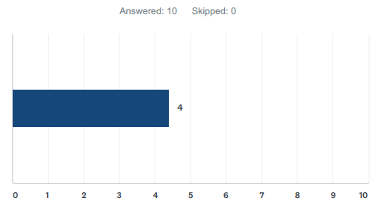

Average of 4.4

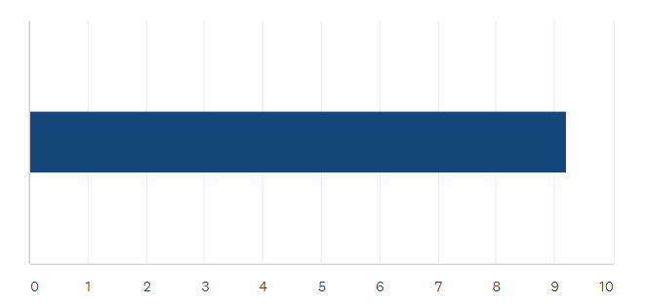Q 08: How important is the existence of a Regional Geospatial Executive Team (RGET) of executives to support, guide, and prioritize the CPA? (0 of no importance, 10 imperative)

Average of 9.2

Q 09: In regards to RGET, what ideas do you have about its purpose, membership, and/or role?

* Provide clear direction on needs for their agency, approve or deny recommendations from the Coordinators, know the value they are getting from the partnership.
* Ensure quick decision making and funding
* I have ideas for an executive/elected official level committee that expands the concept of the RGET. This includes a regional Technology Advisory Committee that would function in the capacity as envisioned with RGET and be inclusive of all services need to support GIS, as well as other vital technology service areas. Membership would include regional executives, elected official and representatives from other committees such as the GIS Coordinator Committee. The purpose would be to provide a central hub for regional technology initiatives and provide coordinated oversight.
* Someone posed a good idea of combining the RGET with other technical committees so executives can be as efficient as possible with their time.
* Purpose: Set high-level priorities and identify future strategic paths. Members should be CIO's or other agency representatives that similarly speak for user/business needs
* (Not my idea but I support it) - Have Executive level (i.e. city manager level) that forms RGET, but they fold the RGET meetings into a master "region" meeting, that includes governance for PAN(public agency network) and other region-wide efforts
* For EWEB it should be the CIO or COO. The purpose should be to provide funds, set general direction, and clear roadblocks at agencies for LCOG.
* The RGET should either be the CEOs or someone just below the CEOs who have the ear of the CEO and access to the CEO. These are the active sponsors. If a critical funding issue come up, these individuals have the power to fund or bring the funding decision to the CEO and/or governing board/council. These individuals can direct resources.

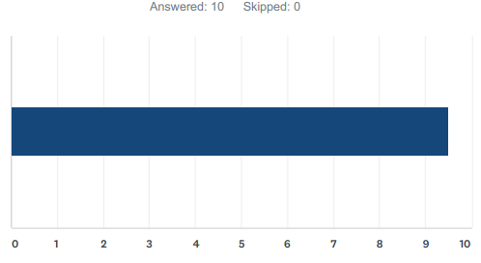Q 10: How important is the existence of a Regional GIS Coordinator’s Team? (0 of no importance, 10 imperative)

Average of 9.5

Q 11: What do you think is the most important functions of the team?

* Track the delivery of the items in the service catalog, address issues, explore new initiatives, coordinate with subcommittees and RGET.
* Bringing information back to clients/partners
* Coordinated development/maintenance the regional GIS program – work plan development, resource planning, budgeting, etc. In terms of specific functions – RLID data maintenance, data acquisition, and software master purchase agreements are top priorities.
* Develop annual work plan
* Agency GIS team-members or direct service consumers.
* To ensure the day to day management of GIS is occurring, as well as ensure the work plan goals are on track to be met
* To implement the direction and strategy of the RGET. Provide recommendations for future years plan and roadmap
* The GIS Coordinators are the technical advisors to the RGET and drive the technical discussions for the CPA.

Q 12: In regards to the GIS Coordinator’s team, what ideas do you have about additional responsibilities, changes, membership, etc.?

* I am open to having a customer as well as technical representation on the team.
* Need members who can commit agencies resources, e.g., dollars to cost-sharing agreements, people to projects, hardware and software resources, etc.
* Communicate with subcommittees to stay informed of progress
* Identify common needs of each partner
* Voting weight based off of contribution to CPA fund
* Needs to be more action vs. status reports. In other words, make the more focused on getting the work done vs. discussion how to get the work done.
* I would add coordinators from additional City departments (e.g. Eugene PDD, 911/Public Safety, Roads), County departments (e.g. S.O., A&T, Surveyor). I would want to add some representatives from utilities.

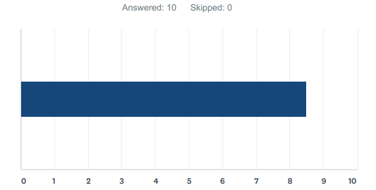Q 13: How important is the existence of a service catalog to the health of the CPA? (0 of no importance, 10 imperative)

Average of 8.5

Q 14: Do you have any comments on the importance of the existence of a service catalog to the health of the CPA?

* It is very hard to manage services that are not well defined.
* Needs to clarify what we are paying for and needs to be simple enough for most to understand.
* We do not have a Service Catalog now .... so we are not aware of the services available and timeline for delivery
* No service catalog, no future health of the CPA, it's a one to one.
* It is impossible to provide transparency into expenditures without articulating the services being provided
* It would seem unsustainable without a service catalog - no mechanism for transparency and trust.

Q 15: Do you have any ideas about how this service catalog should be maintained and socialized?

* Maintained by the LCOG and Coordinators, approved by RGET and documented on RLID website.
* There are several software programs that would help maintain the service catalog
* Maintained by the GIS Coordinators, approved annually by agency execs and socialized periodically (quarterly, 2x a year, ??) with regional executives/elected committees.
* Services which will be provided by LCOG are identified and updated in a formal document and/or web page
* Coordinators maintain and track service need and health. New services needed or old service to be sunset are recommended to executive governance for a final decision.
* Centrally created, and includes feedback from all CPA members - Published on a repeatable basis - include service level agreements based on mutually agreed upon metrics
* Easily accessible online and up to date with statuses of the services within the catalog. Socialized through monthly updates

Q 16: Do you believe that LCOG should continue to be the coordinating entity?

* Coordinator team is the coordinating entity.

Q 17: How do you believe the coordination should be

changed/augmented/improved?

* I think it has been challenging for the LCOG member on the GIS Coordinators to both act as the CPA coordinator and represent LCOG on the committee. If these can be broken apart, it may help.
* Input from all partners with regular meetings
* Have the right people at the table who can commit agency resources to regional initiatives, who understand the value of the shared services to the organization they represent and understand the value of partnerships.
* The coordinating agency needs to be properly resourced to meet the increased demands for services and governance
* Given more power. Implement RGET and new CPA.
* I think there has to be more meaningful participation. There should be regular reporting and a CPA dashboard.

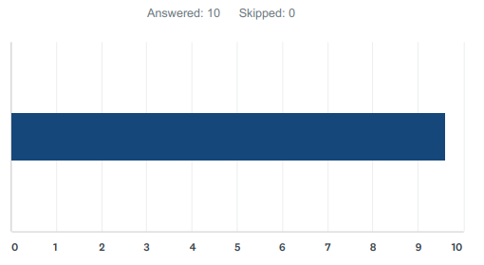Q 18: How important is the existence of an annual work plan to the health of the CPA? (0 of no importance, 10 imperative)

Average of 9.6

Q 19: Do you have any comments on the importance of the existence of an annual work plan to the health of the CPA?

* Need to clearly document how and when the services will be delivered to the partners.
* Workplan milestones and regular reporting to partners. Clear communication and input to deviate from plan Currently it is a nice product - needs some refinement, e.g., alignment with outcomes of this exercise, and simplification for a broader understanding of its content.
* Quarterly or bi-annual progress reports would be good
* The annual work plan needs to annually seek the business needs of the partners
* The work plan must be documented and followed with annual report back and complete transparency where not met or changed.
* The work plan needs to be measured and reported on
* It's critical for agencies to understand how funds are spent on what. Would also be nice to know what was accomplished
* The current plan is overly general and there has been little review/accountability for actions.

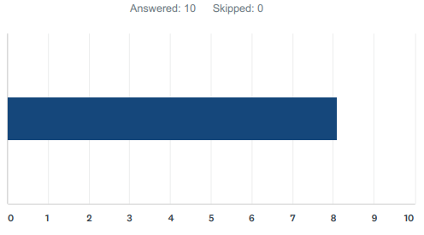Q 20: How important are quarterly financial updates to the health of the CPA? (0 of no importance, 10 imperative)

Average of 8.1

Q 21: Do you have any comments on the importance of quarterly financial updates to the health of the CPA?

* No less than twice per year to inform budget preparation
* Annual or semi-annual seems sufficient
* Quarterly financial updates are good to know if we are on track, provide opportunities to adapt to and/or announce course corrections, seek additional resources, etc.
* The more frequent financial data will allow us to understand the work performed (rather than just reported annually)
* Financial updates should be tied to service catalog and work plan
* Very, this can help member agencies ensure we are properly funding LCOG
* believe there can be no long term trust without financial reporting

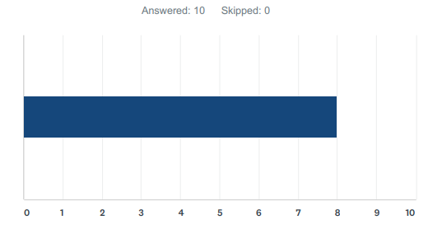Q 22: How important is an annual Voice of the Customer Survey (CPA membership version) and report to the health of the CPA? (0 of no importance, 10 imperative)

Average of 8

Q 23: Do you have any comments on the importance of an annual Voice of the Customer Survey (CPA membership version) and report to the health of the CPA?

* It is hard to set future service plans when we don’t know our customer’s current experience and future needs. Note that customer desires may differ from the expectations of the Coordinators and RGET.
* Results shared with customers
* Annually may be too frequent.
* This is a necessary input to measure, validate, and improve the annual work plan
* If the other mechanisms are functioning, this will be important but just an additional tool in a better toolbox
* VOC Is very important. I would like to understand how revenue generating customers would be included if we are going to survey there needs to be a feedback mechanism to the participants to let them know their voices have been heard and we'll be taken action on.
* If one agency is providing most service, then this is essential, the more decentralized or distributed the services become, the greater the challenge would be for VOTC surveys.

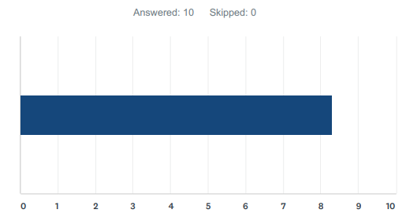Q 24: How important is an annual Key Performance Indicator Update and report to the health of the CPA? (0 of no importance, 10 imperative)

Average of 8.3

Q 25: Do you have any comments on the importance of an annual Key Performance Indicator Update and report to the health of the CPA?

* This is something we can grow into over time. ITIL can be referenced as a starting point.
* Need indicators for managers to keep things on track, need dashboards for regional execs trying to monitor activities.
* This is a necessary input to measure, validate, and improve the annual work plan
* If it's possible to do this, then it means all the other critical things are being done because this won't be possible without a service catalog, workplan, and governance.
* KPIs are essential for us to know if we are meeting our goals

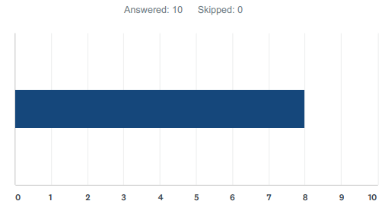Q 26: How important is an annual alignment study (how the CPA aligns with and supports the goals of each agency) and report to the health of the CPA? (0 of no importance, 10 imperative)

Average of 8

Q 27: Do you have any comments on the importance of an annual alignment study (how the CPA aligns with and supports the goals of each agency) and report to the health of the CPA?

* I am seeing this a RGET exercise to use the voice of the customer input with changing organizational goals to adjust the CPA agreement.
* Annual may be too frequent.
* This is a necessary input to validate the level of partner satisfaction
* Ideally, if the RGET and sub committees are meeting and functional we should already be in alignment.

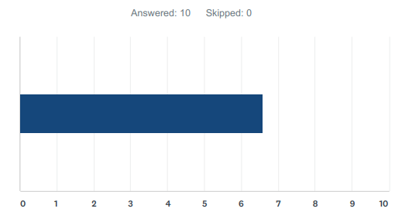Q 28: How important is it for the coordinating agency (LCOG) to take on the role of promoting and incubating innovation to the health of the CPA? (0 of no importance, 10 imperative)

Average of 6.6

Q 29: Do you have any comments on the importance of the coordinating agency (LCOG) to take on the role of promoting and incubating innovation to the health of the CPA?

* I think this role can/should be shared among all partners.
* Incubate/promote public/private partnerships such as OpenData
* We need to address basics first and then evolve the function of promoting and incubating innovation. Then its importance increases.
* The coordinating entity should be the regional coordinator's team
* We see that as LCOG's primary function
* Must be done in collaboration with CPA partners and consistent with partner direction.

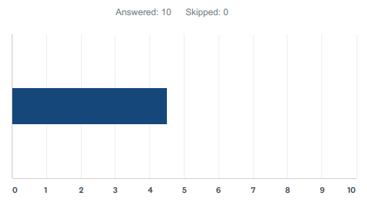Q 30: How supportive are you of the Regional Center of Excellence Model? (0 not at all supportive, 10 very supportive)

Average of 4.5

Q 31: Do you have any comments on the Regional Center of Excellence Model?

* I support the “walk before running” approach. As we prove the ability to effectively provide core services, adding additional services should become a natural growth within the partnership.
* Strive for the excellence model or open data will eventually take away customers
* We need to address basics first and then evolve to a center of excellence. Its importance increases as it evolves. I see this more as a maturity model than a decision point at this time.
* Establish an effective baseline prior to adding the center of excellence components
* We need to focus on re-organizing and improving base partnership model --> "walk before we can run"
* Support for this will grow once basic needs are being met. 6/27/2019 4:53 PM
* Supportive once we have a proven track record of delivering core services
* We need to get the basics down first. Once we have that confidence we can look at Center of Excellence
* We need to meet the basic CPA expectations before we will have significant support for the Center of Excellence Model; Herzberg's two-factor theory/Kano model - partners can't appreciate the above and beyond basic needs, until we're actually meeting the basic needs/expectations.

Q 32: Any other final thoughts or comments?

* Funding is the last step in our process. However, I believe the tension between open data vs. marketing data will continue intruding into the conversation before we get to the funding tasks. Is there a way we can park that conversation in such a way so that everyone on the team will feel comfortable tabling it until the funding work? I feel we need to learn more about our governance and services before having that detailed discussion.
* Nope - thank you and have a good weekend
* Keep up the excellent work - we are fortunate to excellent partners like LCOG.
* CPA is a fantastic collaborative service and CoE is committed to ensuring it remains healthy now and into the future

Governance Conclusion

The overall consensus is to pursue proposed CPA Model 1 (Regional Distribution Model). Once that model is proven to be a success, then elements of Model 2 (Center of Excellence) can be considered. The results of the bi-weekly meetings and online questionnaire should be used to revise CPA Model 1 at the end of Phase III. All of the governance elements identified as Level 1 and 2 priorities are included in CPA Model 1 and after review by the Coordinators have been deemed to be viable and should remain in CPA Model 1. Additional nuances of the various committees have been identified and further defined in this document. One element of the new CPA that was deemed imperative is the formation of the Regional Executive Team (RGET) to provide executive guidance and leadership. The GIS Coordinator’s Group will continue to be the driving force for the tactical implementation of the regional program under the leadership of LCOG. The overall consensus is that sub-committees are needed. However, they should be convened as needed and disbanded after their mission is complete. Various communications methods will need to become a high priority and will be discussed in more detail in the training and education component of Phase III.